**1. Sending SMS using  SmsManager API**

SmsManager smsManager = SmsManager.getDefault();

smsManager.sendTextMessage("", null, "< message body>", null, null);

SmsManager require, SMS_SEND permission in your android mainfeast.  
 ***<uses-permission android:name=”android.permission.SEND_SMS” />***

**2. Sending SMS by invoking Built-in SMS application**

Intent sendIntent = new Intent(Intent.ACTION_VIEW);

sendIntent.putExtra("sms_body", “");

sendIntent.setType("vnd.android-dir/mms-sms");

startActivity(sendIntent);

Follow the complete example for both the method’s  
**activity_main.xml**

<LinearLayout xmlns:android="http://schemas.android.com/apk/res/android"

android:id="@+id/linearLayout1"

android:layout_width="fill_parent"

android:layout_height="fill_parent"

android:orientation="vertical"

android:padding="5dp" >

<TextView

android:layout_width="wrap_content"

android:layout_height="wrap_content"

android:text="Phone Number : "

android:textAppearance="?android:attr/textAppearanceLarge" />

<EditText

android:id="@+id/mobileNumber"

android:layout_width="fill_parent"

android:layout_height="wrap_content"

android:hint="Enter phone number"

android:phoneNumber="true" >

</EditText>

<TextView

android:layout_width="wrap_content"

android:layout_height="wrap_content"

android:text="Message Body: "

android:textAppearance="?android:attr/textAppearanceLarge" />

<EditText

android:id="@+id/smsBody"

android:layout_width="fill_parent"

android:layout_height="wrap_content"

android:gravity="top"

android:hint="Enter message body"

android:inputType="textMultiLine"

android:lines="5" />

<LinearLayout

android:layout_width="fill_parent"

android:layout_height="wrap_content"

android:weightSum="10" >

<Button

android:id="@+id/sendViaIntent"

android:layout_width="fill_parent"

android:layout_height="wrap_content"

android:layout_weight="5"

android:text="SMS Intent" />

<Button

android:id="@+id/send"

android:layout_width="fill_parent"

android:layout_height="wrap_content"

android:layout_weight="5"

android:text="Send" />

</LinearLayout>

</LinearLayout>

**MainActivity.java**

public class MainActivity extends Activity {

private Button shareIntent;

private Button send;

private EditText phoneNo;

private EditText messageBody;

@Override

protected void onCreate(Bundle savedInstanceState) {

super.onCreate(savedInstanceState);

setContentView(R.layout.activity_main);

phoneNo = (EditText) findViewById(R.id.mobileNumber);

messageBody = (EditText) findViewById(R.id.smsBody);

send = (Button) findViewById(R.id.send);

send.setOnClickListener(new OnClickListener() {

@Override

public void onClick(View v) {

String number = phoneNo.getText().toString();

String sms = messageBody.getText().toString();

try {

SmsManager smsManager = SmsManager.getDefault();

smsManager.sendTextMessage(number, null, sms, null, null);

Toast.makeText(getApplicationContext(), "SMS Sent!",

Toast.LENGTH_LONG).show();

} catch (Exception e) {

Toast.makeText(getApplicationContext(),

"SMS faild, please try again later!",

Toast.LENGTH_LONG).show();

e.printStackTrace();

}

}

});

shareIntent = (Button) findViewById(R.id.sendViaIntent);

shareIntent.setOnClickListener(new OnClickListener() {

@Override

public void onClick(View v) {

try {

Intent sendIntent = new Intent(Intent.ACTION_VIEW);

sendIntent.putExtra("sms_body", messageBody.getText().toString());

sendIntent.setType("vnd.android-dir/mms-sms");

startActivity(sendIntent);

} catch (Exception e) {

Toast.makeText(getApplicationContext(),

"SMS faild, please try again later!",

Toast.LENGTH_LONG).show();

e.printStackTrace();

}

}

});

}

@Override

public boolean onCreateOptionsMenu(Menu menu) {

getMenuInflater().inflate(R.menu.main, menu);

return true;

}

}

**3.  Output**

[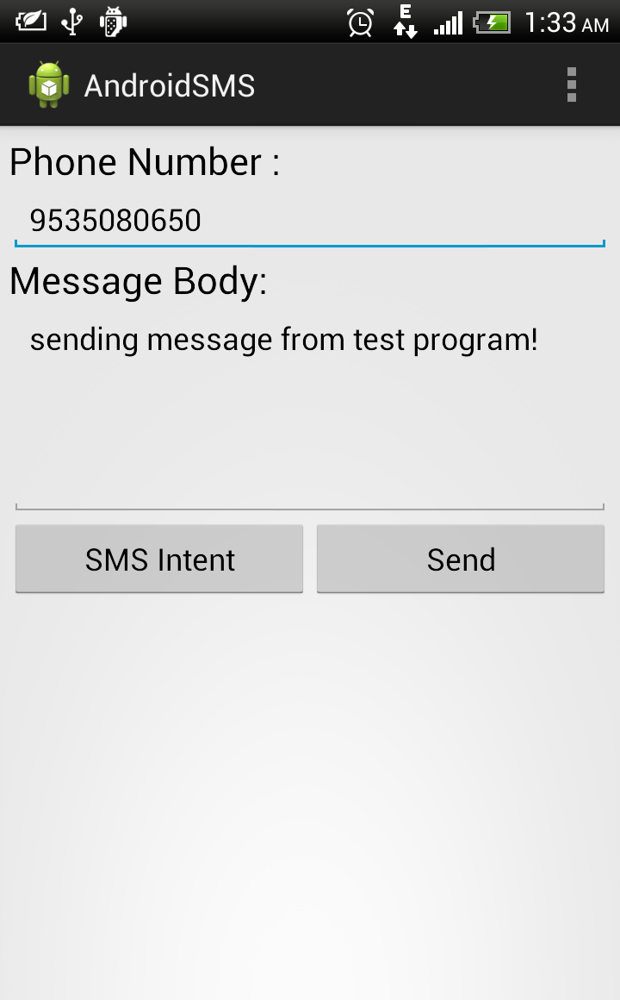](http://st1.vchensubeswogfpjoq.netdna-cdn.com/wp-content/uploads/2013/04/2013-04-29_01-33-08.png)